**Chapter-4**

**IMPLEMENTATION & USER INTERFACE**

**___________________________________________**

This chapter includes various details regarding the implementation and graphical user interface of the complete system. It comprises the screen shots of various windows developed in the project. The user interface part contains the front end and user interface of the system while the implementation contains the backend details of the system like database tables and various functionalities most of which are operated only by the administrator.

**4.1 USER INTERFACE**

This includes the graphical user interface of the system which comprises the various screens which are designed and developed in our project. GUI screens will help you understand the project more illustratively. The user interface part contains the front end and user interface of the system while the implementation contains the backend details of the system like database tables and various functionalities most of which are operated only by the administrator.

**4.1.1 HOME PAGE**

The home page of the project designed by us has been kept simple and precisely limited for the user without adding any unrequired additional tabs and links. It gives user only the information that the user has landed on a page which gives it the ability to use it as per its requirement. Since the page does not contain any futile link so it gives a compact and unambiguous feel to the user while using it

Home page is a gateway to this coding portal for any kind of user whether it is a teacher, student or the administrator himself. For any kind of task required to be done by any of the user it is must for them to visit through this page.

Fig. 4.1: Home Screen for each User

Since the home page has been kept very simple and limited so it can only direct the user either to sign up if the user is new and start using the developed platform as per the requirements and role of the user or to login and continue with his previous proceedings or with new assignments.

**4.1.2 SIGN UP PAGE**

This is the required landing page for all the users which are new for the system. It has also been kept very compact and simple for the user. The fields which are required to be filled in by the user are very few and good enough to contain the required information of the future user of the system. However the teachers themselves cannot signup. This functionality has been given to admin so as to prevent any misuse of system.

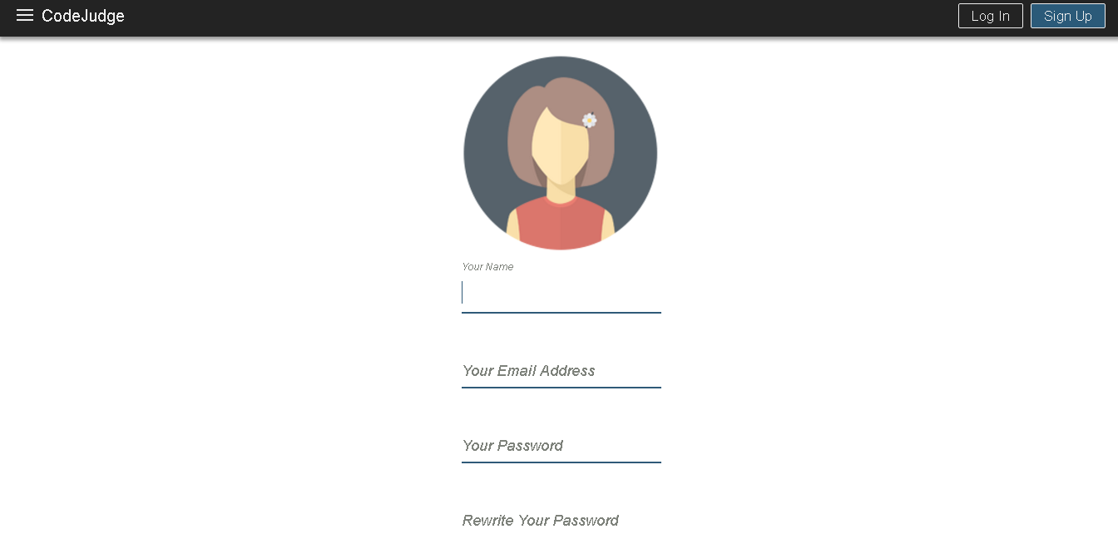Fig. 4.2: Sign Up Page

The fields which are required to be filled in are Name, E-Mail Id, Password and Password Confirmation before submitting the page. The above mentioned fields are good enough to meet the minimum information requirement criteria for the system to know the user.